NAME: Shriya Ramya Mohan
ROLL NO.: 241901106

EXPERIMENT 1
CAPTURE FLAGS-ENCRYPTION CRYPTO 101

AIM:
To capture the various flags in Encryption Crypto 101 in TryHackMe platform.

ALGORITHM:
1. Access the Encryption Crypto 101 lab in TryHackMe platform using the link below-
https://tryhackme.com/r/room/encryptioncrypto101
2. Click Start AttackBox to run the instance of Kali Linux distribution.
3. Solve the crypto math used in RSA.
4. Find out who issued the HTTPS Certificate to tryhackme.com
5. Perform SSH Authentication by generating public and private key pair using ssh-keygen
6. Perform decryption of the jpg encrypted file and find out the secret word.

OUTPUT:
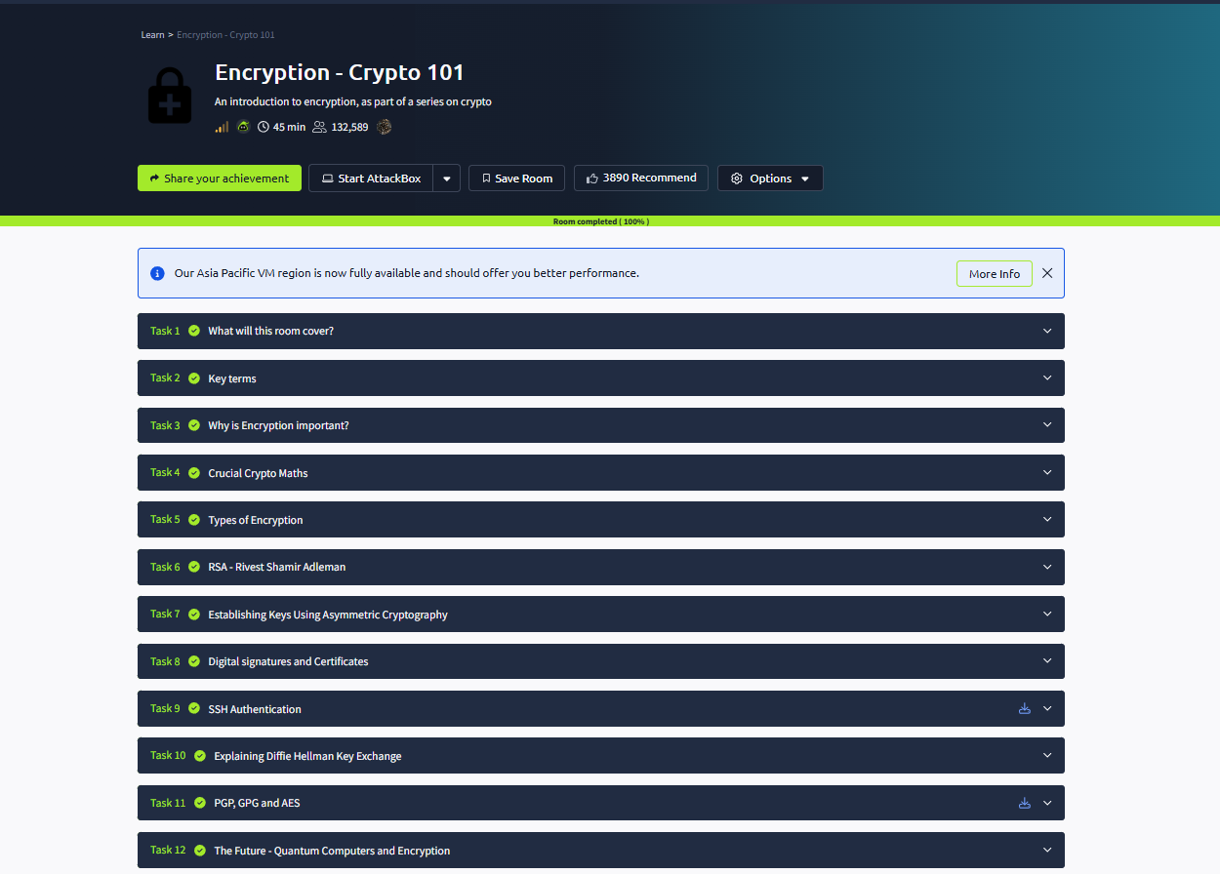
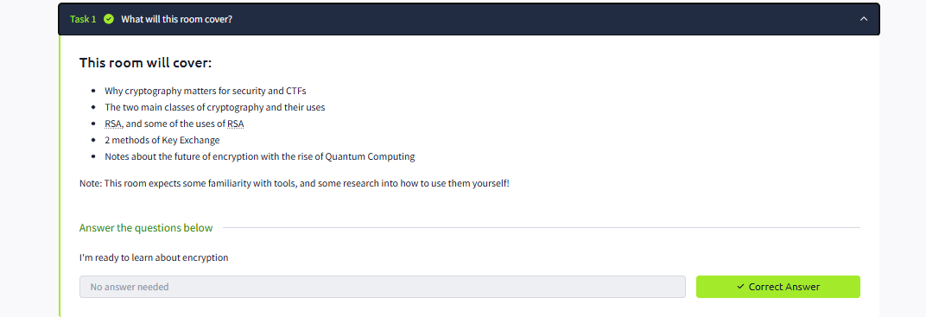
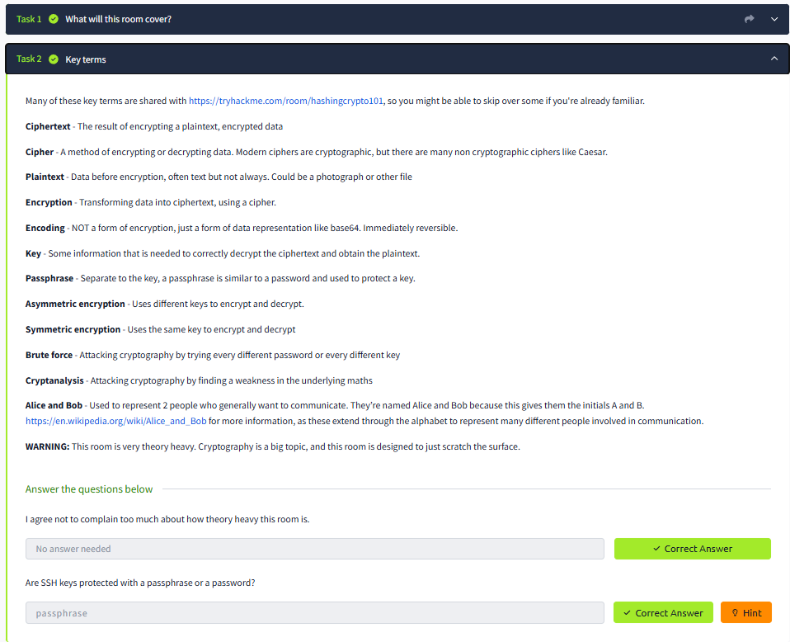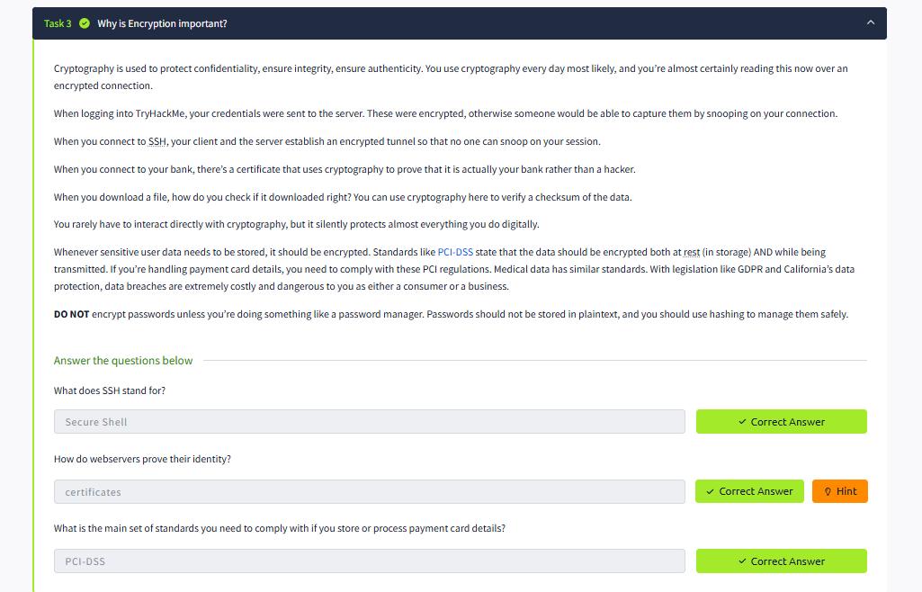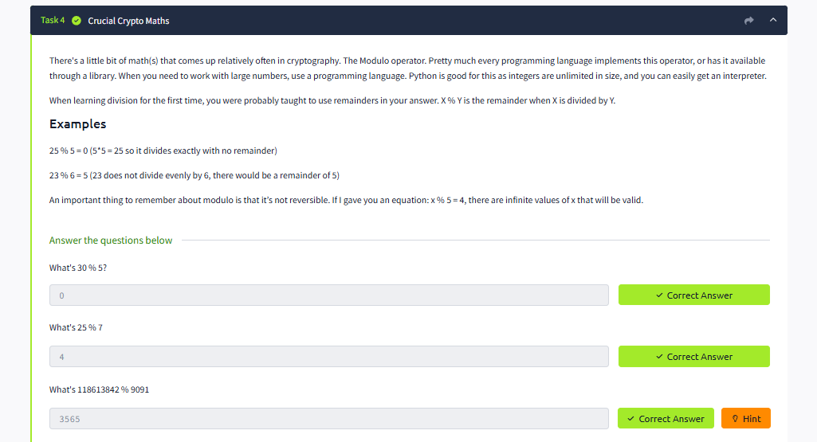
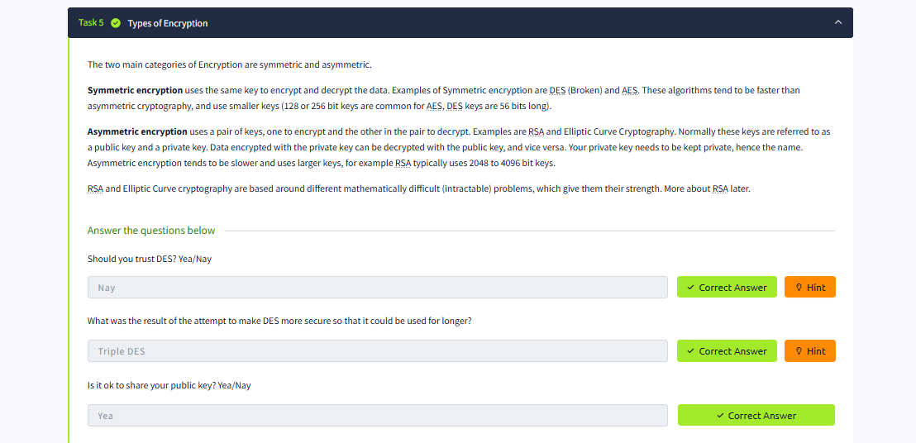
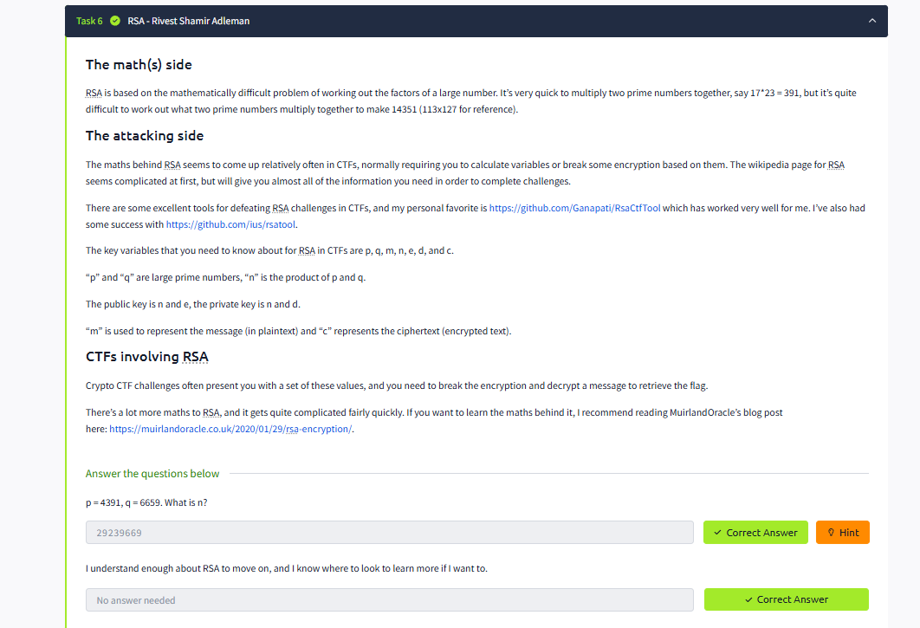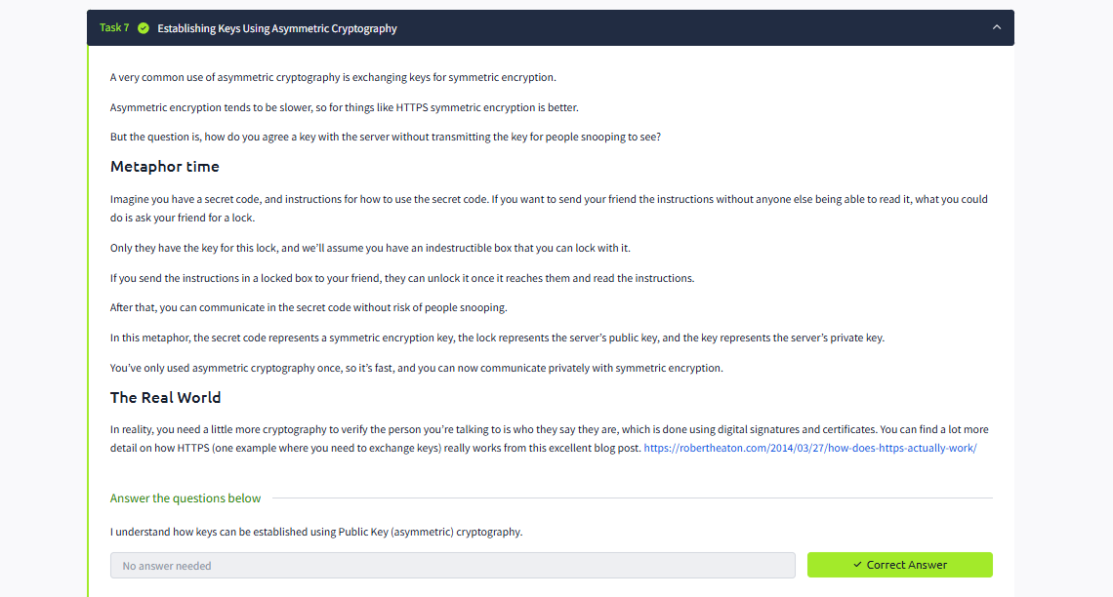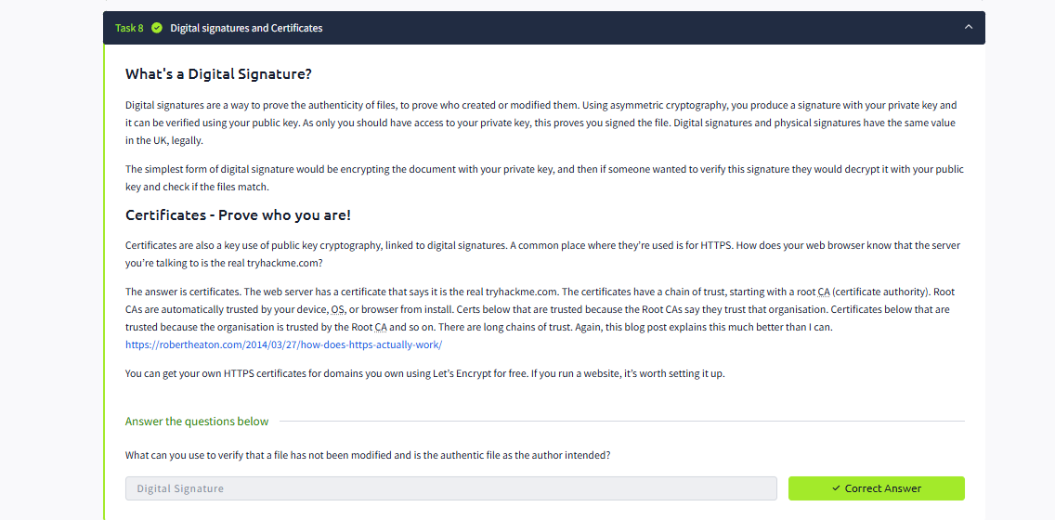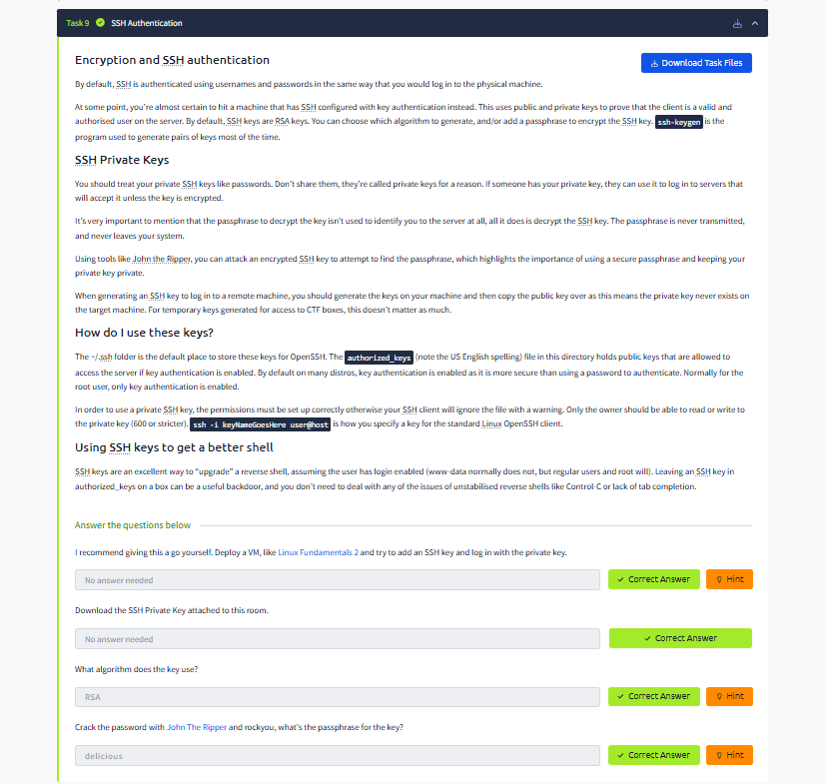
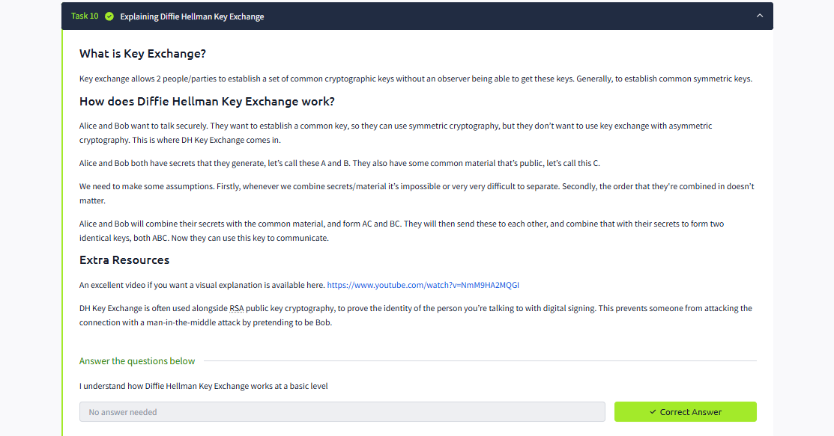
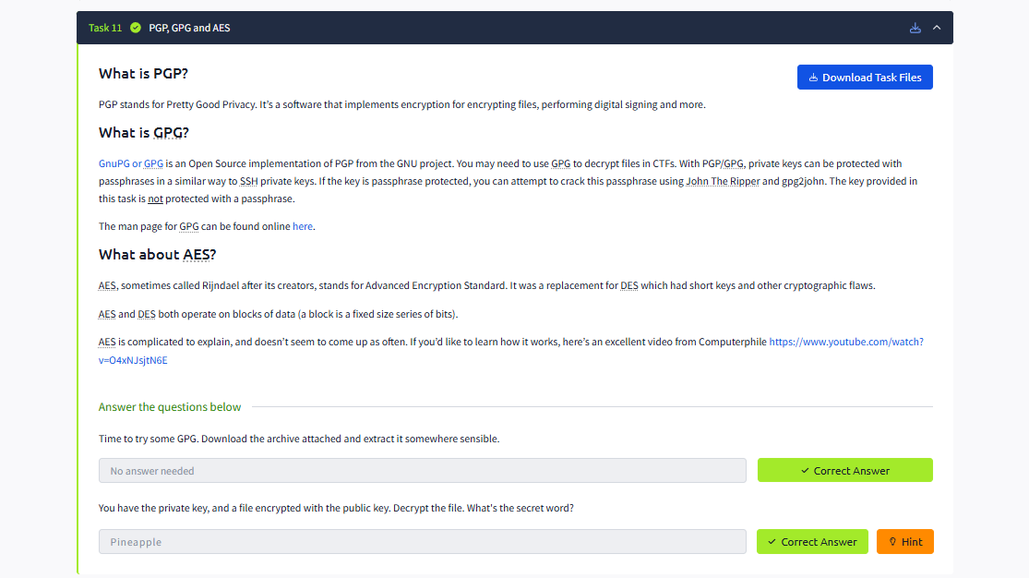
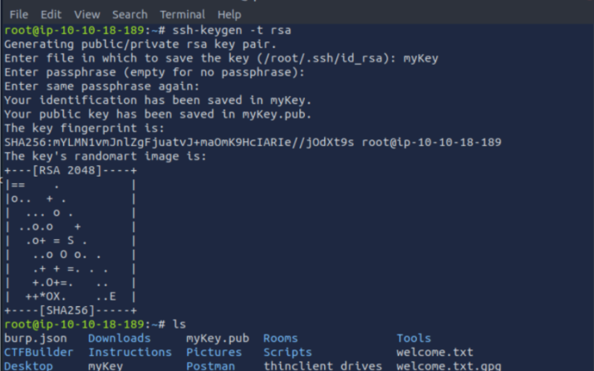

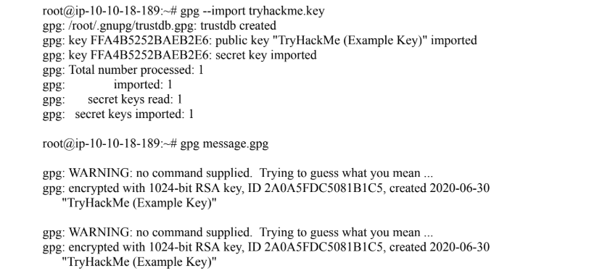

RESULT:
Thus, the various flags have been captured in Encryption Crypto 101 in TryHackMe platform.

